The Power of Data: 15% Energy Saving through Measurement and Planning
Industry: Agrifood Manufacturing
Focus: Steam System Efficiency and Operational Planning

● At a Glance
- Achieved 15% reduction in heavy fuel consumption per ton of product
- Introduced SCADA and MES to enable data-driven operational decisions
- Improved maintenance execution through better visibility and planning
- Shifted production policy from reactive cost-cutting to proactive energy efficiency
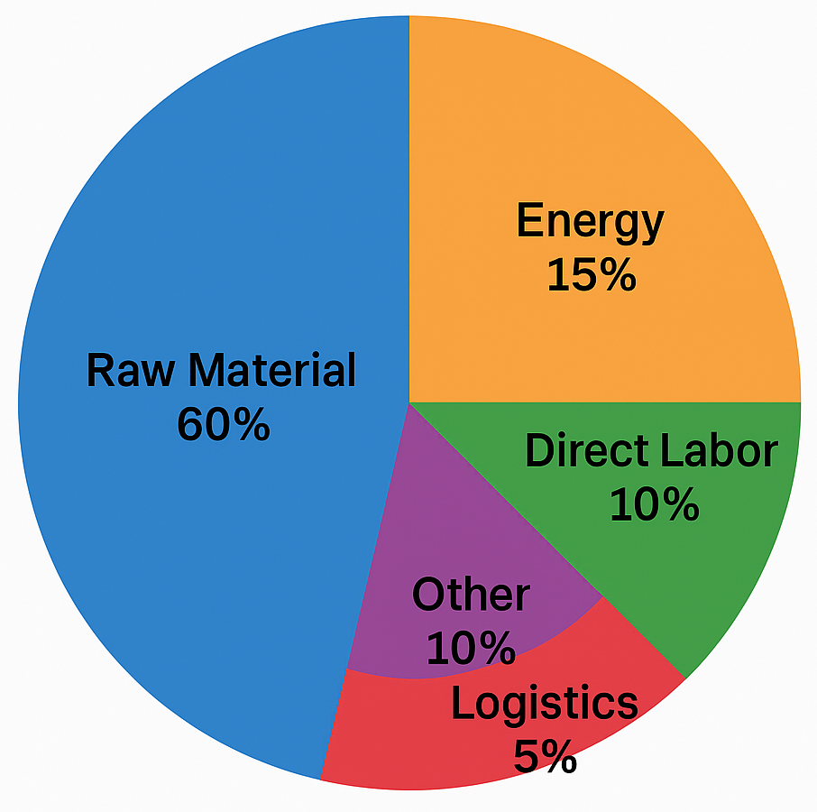

🏭 The Situation
The plant operated in the agrifood sector, where steam accounted for around 15% of total production costs. Despite its significance, energy use was treated simplistically: cost-cutting meant “closing valves” or shutting operations to avoid wage premiums. Production decisions often prioritized short-term expense over output efficiency, without visibility into the true cost of interruptions and restarts.
The steam system suffered from zero-load energy waste—fuel spent just to maintain readiness—and a lack of basic instrumentation. SCADA infrastructure was outdated and there was no MES in place. Deferred maintenance had left insulation degraded and heat exchangers corroded or bypassed entirely. With separate departments managing boiler and process systems, systemic waste went unnoticed.
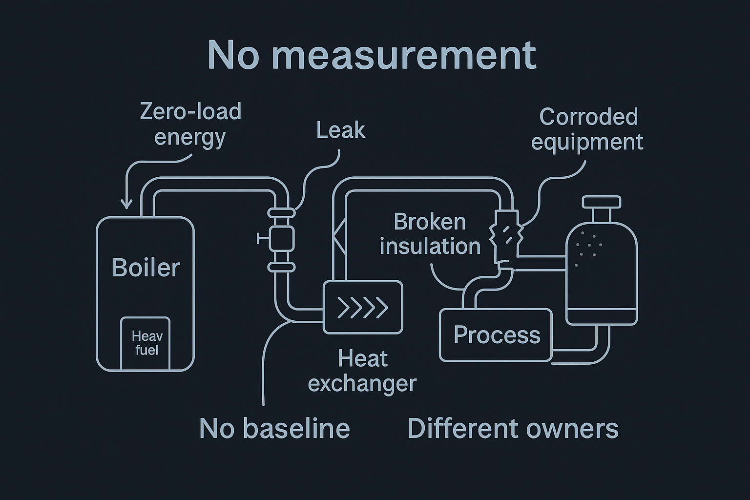

❌ The Challenge
The challenge was to lower the fuel cost per ton of product without reducing operational capacity or delivery reliability. This required overcoming years of reactive practices, unclear data, and neglected maintenance. The steam system had intrinsic inefficiencies and operating habits that intensified energy waste, especially during production restarts. Without measurement, real costs remained hidden.

🔬 The Underlying Theory
Steam system efficiency rests on two domains: production and utilization. On the production side, factors like burner tuning, economizers, blowdowns, and heat transfer surface condition drive fuel-to-steam efficiency. These are typically benchmarked against historical performance or industry standards.
Utilization, however, is often overlooked. It includes heat losses, leaks, degraded insulation, and idle-time energy use. These elements are diffuse, harder to quantify, and frequently fall outside the boiler department's scope. As a result, many organizations optimize steam generation while neglecting how that steam is used.
A well-functioning steam system demands balanced attention to both ends. Real savings come not just from burning fuel more efficiently, but from using steam more purposefully.

🔧 Our Approach
The first intervention was structural: introducing proper measurement and reporting. We upgraded the SCADA system and implemented a MES—uncommon in this industry at the time. This gave clear tracking of steam use per ton of output, allowing for accurate baseline definition and performance monitoring.
With this foundation, three key initiatives were launched:

Maintenance and Housekeeping
We established a yearly plan to clean and monitor all heat exchangers. One had been bypassed for 25 years due to corrosion and was doing no useful work. Insulation across the plant was audited, repaired, and placed under an annual budgeted upkeep plan.

Planning Policy
We introduced a simple but high-leverage rule: the plant would only restart on Saturday night if it had production scheduled for a full week. This required better coordination and sales forecasting, but dramatically increased the steam-to-product ratio efficiency.

Cross-functional Enablement
Improved visibility and data access allowed planning, maintenance, and operations to align. This removed legacy silos and made better decisions possible across departments.
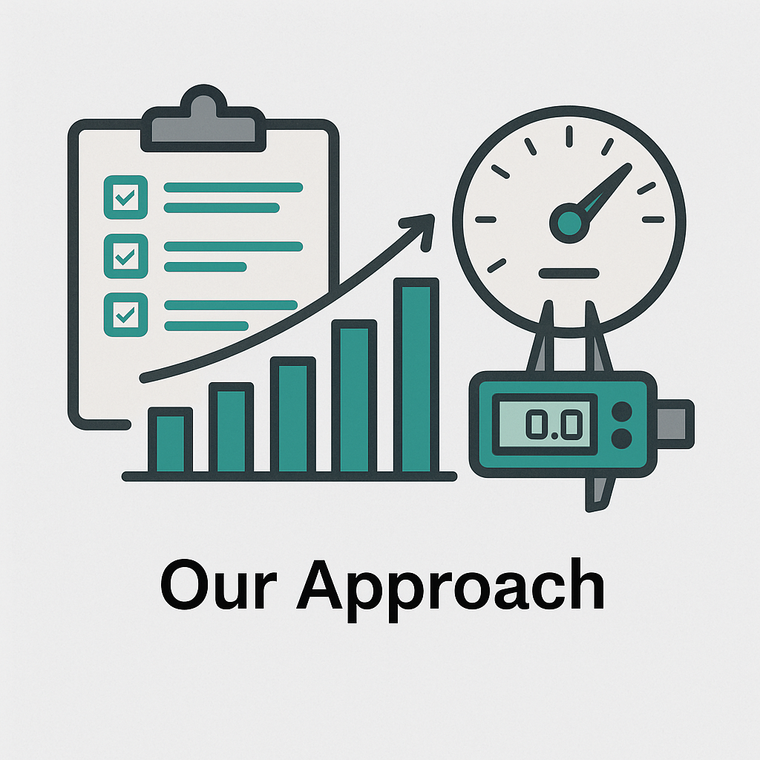

✅ The Results
- 15% reduction in heavy fuel consumption per ton of product
- Stabilized maintenance cycle, reducing insulation losses and improving heat recovery
- Enabled long-term operational planning through accurate data visibility
- Cultural shift from energy avoidance to output efficiency
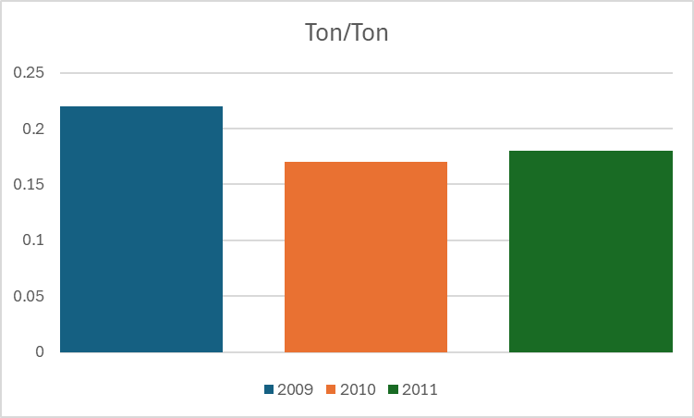

💡 Takeaway
- Data Is a Lever
Introducing SCADA and MES wasn’t about technology—it was about changing minds. The simple act of seeing energy consumption per output made inefficiencies visible and actionable. Data closed the gap between intention and execution.
- Fix What You’re Not Measuring
Leakage, insulation loss, corroded assets—these don’t show up unless you’re looking. Maintenance became strategic once performance metrics were tied to operational cost per ton.
- Plan Like Energy Matters
The biggest saving came not from the boilers, but from the boardroom. By tying restarts to full-week production, we turned fixed energy costs into productive output. Planning became the central tool of energy efficiency.

Written by Yair Riffkin. With over two decades of experience in operational performance, manufacturing technology, and data-driven process transformation across global industries.
🔗 Connect with me on Linkedin
🌐 Visit Yeda Solutions

